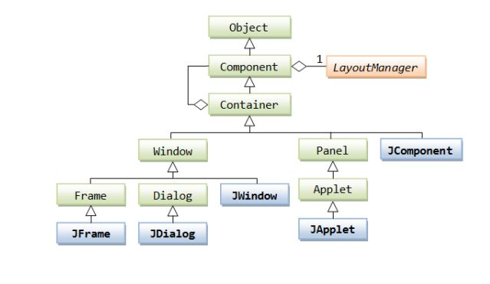
Object
Component
LayoutManager
Container
Window
Panel
JComponent
Applet
Frame
Dialog
JWindow
JFrame
JDialog
JApplet

